**Software Engineering Semester 3**

**Design Document**

**UI Feedback**

May 2021

Spartex

Table of Contents

Introduction 3

Feedback Gotten 3

Improvements 4

Content in pages need to be centralised and consistent 4

Keep a consistent font styling 4

Move the navbar from a side navbar to a horizontal navbar 5

Make the logo on the navbar smaller 5

Why not go for a plain nav bar instead of one with colour 5

Reduce the font size of the nav bar text 5

On the Graduation Year and Class management pages the UI needs a lot of work why not put the textbox and button in a form 6

Feedback after an admin adds another user should be present 7

# Introduction

This document contains the feedback gotten from fellow peers apart my UI before its current state

# Feedback Gotten

1. Content in pages need to be centralised and consistent
2. Keep a consistent font styling
3. Move the navbar from a side navbar to a horizontal navbar
4. Make the logo on the navbar smaller
5. Why not go for a plain nav bar instead of one with colour
6. Reduce the font size of the nav bar text
7. On the Graduation Year and Class management pages the UI needs a lot of work why not put the textbox and button in a form
8. Feedback after an admin adds another user should be present
9. Why not have the login page redirect the user especially the admin to a page that is vital for him to see at start up
10. Add a profile info page for the user which just logged in
11. Auto generate the user password
12. Add the Logout button to the side of the navbar

# Improvements

## Content in pages need to be centralised and consistent

As seen form all the screenshots the content in all pages is now more in the centre

## Keep a consistent font styling

As seen from the screen shots a more consistent font styling has been used

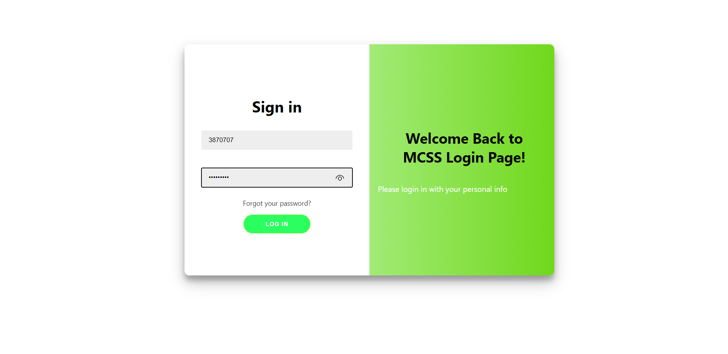

## Move the navbar from a side navbar to a horizontal navbar

## Make the logo on the navbar smaller

## Why not go for a plain nav bar instead of one with colour

## Reduce the font size of the nav bar text

As seen from the screenshot below

* The former side navbar has been moved to a horizontal nav bar
* the logo has been made smaller
* A plain background is being used for the nav bar
* The font size of the text on the navbar has been reduced

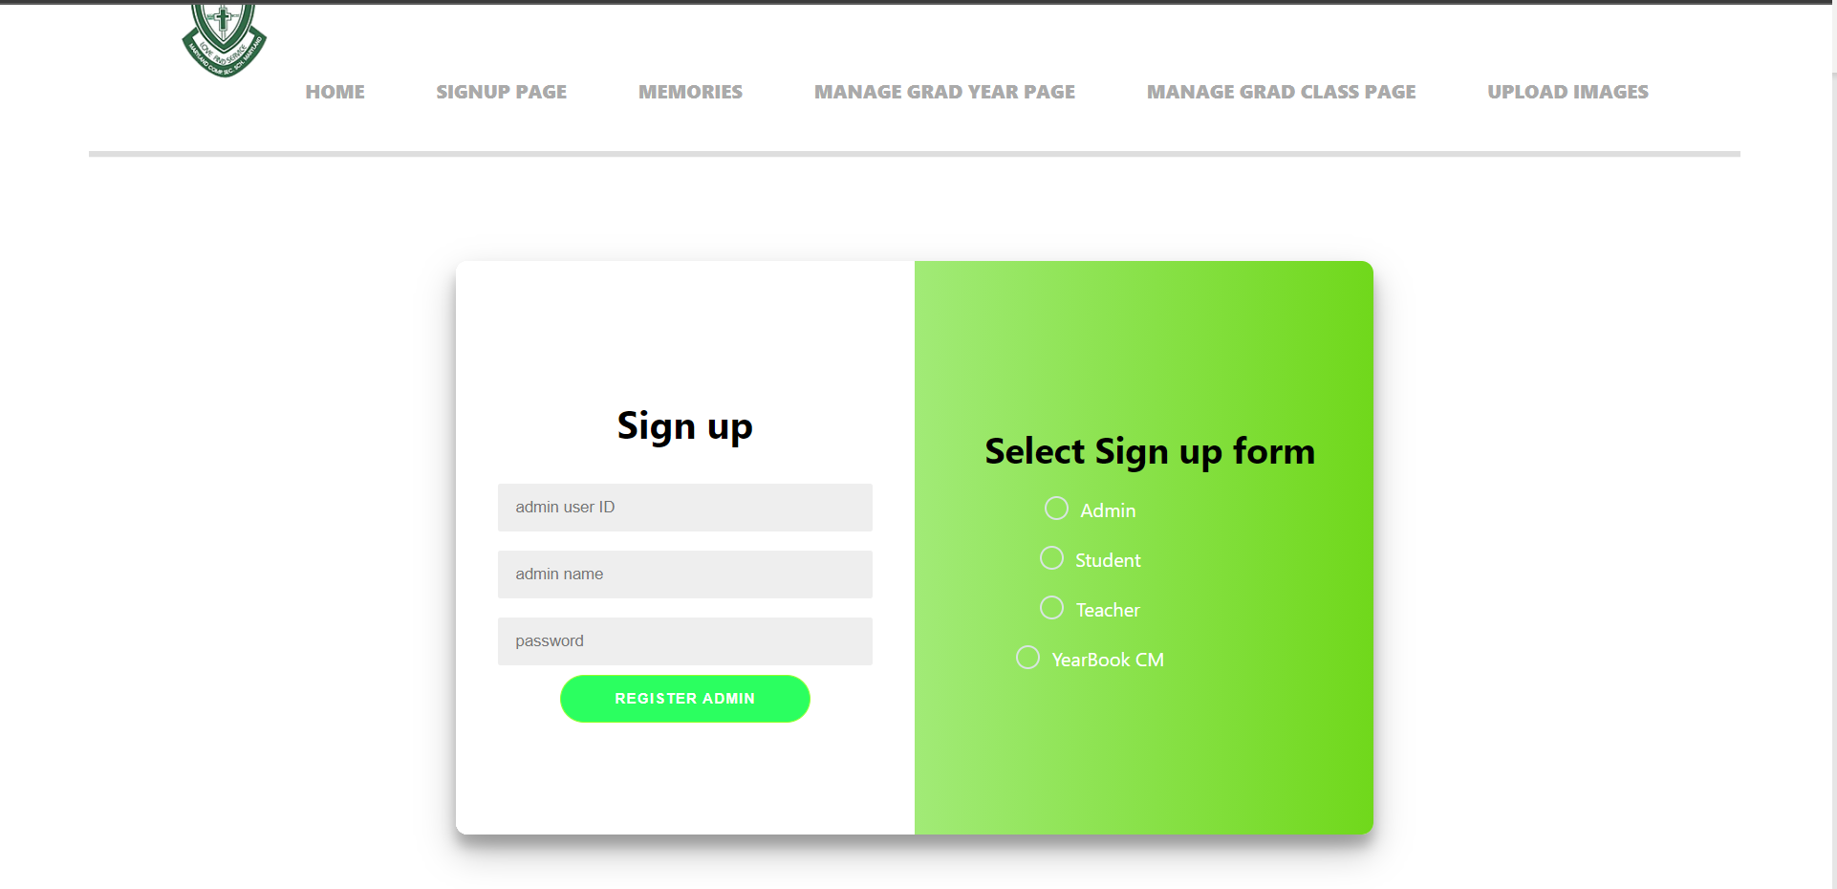

## On the Graduation Year and Class management pages the UI needs a lot of work why not put the textbox and button in a form

Seen from the screenshot below:

* The UI of the graduation class and graduation year management pages has been changed to look a bit better than before
* The text boxes and button for both have been inserted in a form

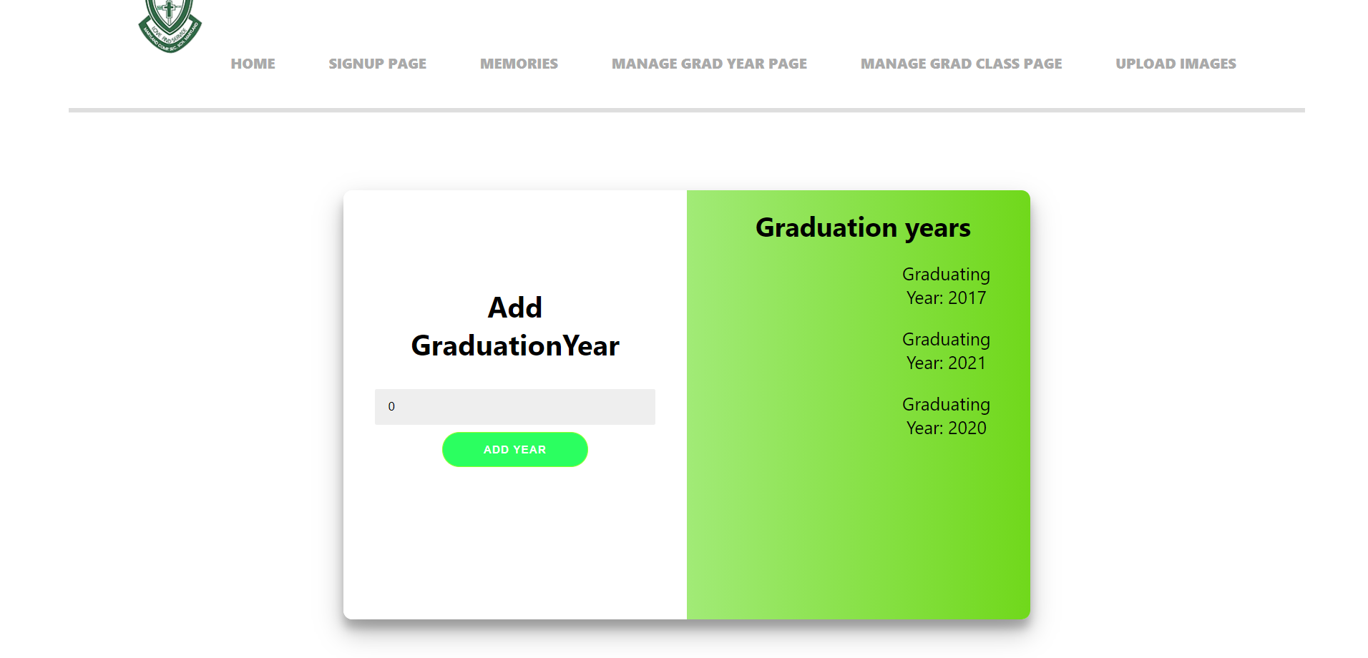

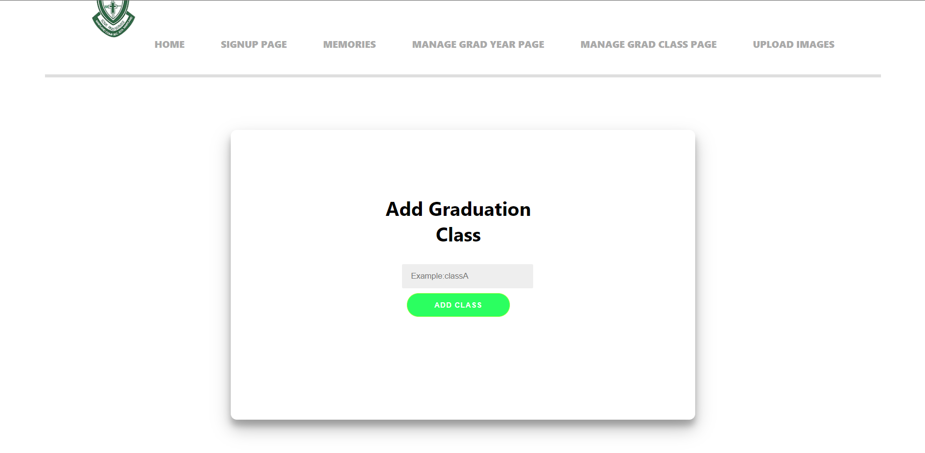

## Feedback after an admin adds another user should be present

Now when an admin adds another user he gets feedback if the user was added

